Отчет к лабораторной работе №2

Гатальский Дмитрий Витальевич 251001

Вариант:3

Длинна:25

*P*(*x*) = *x*25 +*x*3 + 1

|  |  |  |  |  |  |  |  |  |  |  |  |  |  |  |  |  |  |  |  |  |  |  |  |  |  |  |  |
| --- | --- | --- | --- | --- | --- | --- | --- | --- | --- | --- | --- | --- | --- | --- | --- | --- | --- | --- | --- | --- | --- | --- | --- | --- | --- | --- | --- |
|  |  | Степени | | | | | | | | | | | | | | | | | | | | | | | | | xor |
|  |  | 25 | 24 | 23 | 22 | 21 | 20 | 19 | 18 | 17 | 16 | 15 | 14 | 13 | 12 | 11 | 10 | 9 | 8 | 7 | 6 | 5 | 4 | 3 | 2 | 1 |  |
| Шаги / Состояние регистра | 1 | 1 | 1 | 1 | 1 | 1 | 1 | 1 | 1 | 1 | 1 | 1 | 1 | 1 | 1 | 1 | 1 | 1 | 1 | 1 | 1 | 1 | 1 | 1 | 1 | 1 | 0 |
| 2 | 1 | 1 | 1 | 1 | 1 | 1 | 1 | 1 | 1 | 1 | 1 | 1 | 1 | 1 | 1 | 1 | 1 | 1 | 1 | 1 | 1 | 1 | 1 | 1 | 0 | 0 |
| 3 | 1 | 1 | 1 | 1 | 1 | 1 | 1 | 1 | 1 | 1 | 1 | 1 | 1 | 1 | 1 | 1 | 1 | 1 | 1 | 1 | 1 | 1 | 1 | 0 | 0 | 0 |
| 4 | 1 | 1 | 1 | 1 | 1 | 1 | 1 | 1 | 1 | 1 | 1 | 1 | 1 | 1 | 1 | 1 | 1 | 1 | 1 | 1 | 1 | 1 | 0 | 0 | 0 | 1 |
| 5 | 1 | 1 | 1 | 1 | 1 | 1 | 1 | 1 | 1 | 1 | 1 | 1 | 1 | 1 | 1 | 1 | 1 | 1 | 1 | 1 | 1 | 0 | 0 | 0 | 1 | 1 |
| 6 | 1 | 1 | 1 | 1 | 1 | 1 | 1 | 1 | 1 | 1 | 1 | 1 | 1 | 1 | 1 | 1 | 1 | 1 | 1 | 1 | 0 | 0 | 0 | 1 | 1 | 1 |
| 7 | 1 | 1 | 1 | 1 | 1 | 1 | 1 | 1 | 1 | 1 | 1 | 1 | 1 | 1 | 1 | 1 | 1 | 1 | 1 | 0 | 0 | 0 | 1 | 1 | 1 | 0 |
| 8 | 1 | 1 | 1 | 1 | 1 | 1 | 1 | 1 | 1 | 1 | 1 | 1 | 1 | 1 | 1 | 1 | 1 | 1 | 0 | 0 | 0 | 1 | 1 | 1 | 0 | 0 |
| 9 | 1 | 1 | 1 | 1 | 1 | 1 | 1 | 1 | 1 | 1 | 1 | 1 | 1 | 1 | 1 | 1 | 1 | 0 | 0 | 0 | 1 | 1 | 1 | 0 | 0 | 0 |
| 10 | 1 | 1 | 1 | 1 | 1 | 1 | 1 | 1 | 1 | 1 | 1 | 1 | 1 | 1 | 1 | 1 | 0 | 0 | 0 | 1 | 1 | 1 | 0 | 0 | 0 | 1 |
| 11 | 1 | 1 | 1 | 1 | 1 | 1 | 1 | 1 | 1 | 1 | 1 | 1 | 1 | 1 | 1 | 0 | 0 | 0 | 1 | 1 | 1 | 0 | 0 | 0 | 1 | 1 |
| 12 | 1 | 1 | 1 | 1 | 1 | 1 | 1 | 1 | 1 | 1 | 1 | 1 | 1 | 1 | 0 | 0 | 0 | 1 | 1 | 1 | 0 | 0 | 0 | 1 | 1 | 1 |
| 13 | 1 | 1 | 1 | 1 | 1 | 1 | 1 | 1 | 1 | 1 | 1 | 1 | 1 | 0 | 0 | 0 | 1 | 1 | 1 | 0 | 0 | 0 | 1 | 1 | 1 | 0 |
| 14 | 1 | 1 | 1 | 1 | 1 | 1 | 1 | 1 | 1 | 1 | 1 | 1 | 0 | 0 | 0 | 1 | 1 | 1 | 0 | 0 | 0 | 1 | 1 | 1 | 0 | 0 |
| 15 | 1 | 1 | 1 | 1 | 1 | 1 | 1 | 1 | 1 | 1 | 1 | 0 | 0 | 0 | 1 | 1 | 1 | 0 | 0 | 0 | 1 | 1 | 1 | 0 | 0 | 0 |
| 16 | 1 | 1 | 1 | 1 | 1 | 1 | 1 | 1 | 1 | 1 | 0 | 0 | 0 | 1 | 1 | 1 | 0 | 0 | 0 | 1 | 1 | 1 | 0 | 0 | 0 | 1 |
| 17 | 1 | 1 | 1 | 1 | 1 | 1 | 1 | 1 | 1 | 0 | 0 | 0 | 1 | 1 | 1 | 0 | 0 | 0 | 1 | 1 | 1 | 0 | 0 | 0 | 1 | 1 |
| 18 | 1 | 1 | 1 | 1 | 1 | 1 | 1 | 1 | 0 | 0 | 0 | 1 | 1 | 1 | 0 | 0 | 0 | 1 | 1 | 1 | 0 | 0 | 0 | 1 | 1 | 1 |
| 19 | 1 | 1 | 1 | 1 | 1 | 1 | 1 | 0 | 0 | 0 | 1 | 1 | 1 | 0 | 0 | 0 | 1 | 1 | 1 | 0 | 0 | 0 | 1 | 1 | 1 | 0 |
| 20 | 1 | 1 | 1 | 1 | 1 | 1 | 0 | 0 | 0 | 1 | 1 | 1 | 0 | 0 | 0 | 1 | 1 | 1 | 0 | 0 | 0 | 1 | 1 | 1 | 0 | 0 |
| 21 | 1 | 1 | 1 | 1 | 1 | 0 | 0 | 0 | 1 | 1 | 1 | 0 | 0 | 0 | 1 | 1 | 1 | 0 | 0 | 0 | 1 | 1 | 1 | 0 | 0 | 0 |
| 22 | 1 | 1 | 1 | 1 | 0 | 0 | 0 | 1 | 1 | 1 | 0 | 0 | 0 | 1 | 1 | 1 | 0 | 0 | 0 | 1 | 1 | 1 | 0 | 0 | 0 | 1 |
| 23 | 1 | 1 | 1 | 0 | 0 | 0 | 1 | 1 | 1 | 0 | 0 | 0 | 1 | 1 | 1 | 0 | 0 | 0 | 1 | 1 | 1 | 0 | 0 | 0 | 1 | 1 |
| 24 | 1 | 1 | 0 | 0 | 0 | 1 | 1 | 1 | 0 | 0 | 0 | 1 | 1 | 1 | 0 | 0 | 0 | 1 | 1 | 1 | 0 | 0 | 0 | 1 | 1 | 1 |
| 25 | 1 | 0 | 0 | 0 | 1 | 1 | 1 | 0 | 0 | 0 | 1 | 1 | 1 | 0 | 0 | 0 | 1 | 1 | 1 | 0 | 0 | 0 | 1 | 1 | 1 | 0 |
| 26 | 0 | 0 | 0 | 1 | 1 | 1 | 0 | 0 | 0 | 1 | 1 | 1 | 0 | 0 | 0 | 1 | 1 | 1 | 0 | 0 | 0 | 1 | 1 | 1 | 0 | 1 |
| 27 | 0 | 0 | 1 | 1 | 1 | 0 | 0 | 0 | 1 | 1 | 1 | 0 | 0 | 0 | 1 | 1 | 1 | 0 | 0 | 0 | 1 | 1 | 1 | 0 | 1 | 1 |
| 28 | 0 | 1 | 1 | 1 | 0 | 0 | 0 | 1 | 1 | 1 | 0 | 0 | 0 | 1 | 1 | 1 | 0 | 0 | 0 | 1 | 1 | 1 | 0 | 1 | 1 | 0 |
| 29 | 1 | 1 | 1 | 0 | 0 | 0 | 1 | 1 | 1 | 0 | 0 | 0 | 1 | 1 | 1 | 0 | 0 | 0 | 1 | 1 | 1 | 0 | 1 | 1 | 0 | 0 |
| 30 | 1 | 1 | 0 | 0 | 0 | 1 | 1 | 1 | 0 | 0 | 0 | 1 | 1 | 1 | 0 | 0 | 0 | 1 | 1 | 1 | 0 | 1 | 1 | 0 | 0 | 0 |
| 31 | 1 | 0 | 0 | 0 | 1 | 1 | 1 | 0 | 0 | 0 | 1 | 1 | 1 | 0 | 0 | 0 | 1 | 1 | 1 | 0 | 1 | 1 | 0 | 0 | 0 | 1 |
| 32 | 0 | 0 | 0 | 1 | 1 | 1 | 0 | 0 | 0 | 1 | 1 | 1 | 0 | 0 | 0 | 1 | 1 | 1 | 0 | 1 | 1 | 0 | 0 | 0 | 1 | 0 |
| 33 | 0 | 0 | 1 | 1 | 1 | 0 | 0 | 0 | 1 | 1 | 1 | 0 | 0 | 0 | 1 | 1 | 1 | 0 | 1 | 1 | 0 | 0 | 0 | 1 | 0 | 0 |
| 34 | 0 | 1 | 1 | 1 | 0 | 0 | 0 | 1 | 1 | 1 | 0 | 0 | 0 | 1 | 1 | 1 | 0 | 1 | 1 | 0 | 0 | 0 | 1 | 0 | 0 | 1 |
| 35 | 1 | 1 | 1 | 0 | 0 | 0 | 1 | 1 | 1 | 0 | 0 | 0 | 1 | 1 | 1 | 0 | 1 | 1 | 0 | 0 | 0 | 1 | 0 | 0 | 1 | 1 |
| 36 | 1 | 1 | 0 | 0 | 0 | 1 | 1 | 1 | 0 | 0 | 0 | 1 | 1 | 1 | 0 | 1 | 1 | 0 | 0 | 0 | 1 | 0 | 0 | 1 | 1 | 1 |
| 37 | 1 | 0 | 0 | 0 | 1 | 1 | 1 | 0 | 0 | 0 | 1 | 1 | 1 | 0 | 1 | 1 | 0 | 0 | 0 | 1 | 0 | 0 | 1 | 1 | 1 | 0 |
| 38 | 0 | 0 | 0 | 1 | 1 | 1 | 0 | 0 | 0 | 1 | 1 | 1 | 0 | 1 | 1 | 0 | 0 | 0 | 1 | 0 | 0 | 1 | 1 | 1 | 0 | 1 |
| 39 | 0 | 0 | 1 | 1 | 1 | 0 | 0 | 0 | 1 | 1 | 1 | 0 | 1 | 1 | 0 | 0 | 0 | 1 | 0 | 0 | 1 | 1 | 1 | 0 | 1 | 1 |
| 40 | 0 | 1 | 1 | 1 | 0 | 0 | 0 | 1 | 1 | 1 | 0 | 1 | 1 | 0 | 0 | 0 | 1 | 0 | 0 | 1 | 1 | 1 | 0 | 1 | 1 | 0 |
| 41 | 1 | 1 | 1 | 0 | 0 | 0 | 1 | 1 | 1 | 0 | 1 | 1 | 0 | 0 | 0 | 1 | 0 | 0 | 1 | 1 | 1 | 0 | 1 | 1 | 0 | 0 |
| 42 | 1 | 1 | 0 | 0 | 0 | 1 | 1 | 1 | 0 | 1 | 1 | 0 | 0 | 0 | 1 | 0 | 0 | 1 | 1 | 1 | 0 | 1 | 1 | 0 | 0 | 0 |
| 43 | 1 | 0 | 0 | 0 | 1 | 1 | 1 | 0 | 1 | 1 | 0 | 0 | 0 | 1 | 0 | 0 | 1 | 1 | 1 | 0 | 1 | 1 | 0 | 0 | 0 | 1 |
| 44 | 0 | 0 | 0 | 1 | 1 | 1 | 0 | 1 | 1 | 0 | 0 | 0 | 1 | 0 | 0 | 1 | 1 | 1 | 0 | 1 | 1 | 0 | 0 | 0 | 1 | 0 |
| 45 | 0 | 0 | 1 | 1 | 1 | 0 | 1 | 1 | 0 | 0 | 0 | 1 | 0 | 0 | 1 | 1 | 1 | 0 | 1 | 1 | 0 | 0 | 0 | 1 | 0 | 0 |
| 46 | 0 | 1 | 1 | 1 | 0 | 1 | 1 | 0 | 0 | 0 | 1 | 0 | 0 | 1 | 1 | 1 | 0 | 1 | 1 | 0 | 0 | 0 | 1 | 0 | 0 | 1 |
| 47 | 1 | 1 | 1 | 0 | 1 | 1 | 0 | 0 | 0 | 1 | 0 | 0 | 1 | 1 | 1 | 0 | 1 | 1 | 0 | 0 | 0 | 1 | 0 | 0 | 1 | 1 |
| 48 | 1 | 1 | 0 | 1 | 1 | 0 | 0 | 0 | 1 | 0 | 0 | 1 | 1 | 1 | 0 | 1 | 1 | 0 | 0 | 0 | 1 | 0 | 0 | 1 | 1 | 1 |
| 49 | 1 | 0 | 1 | 1 | 0 | 0 | 0 | 1 | 0 | 0 | 1 | 1 | 1 | 0 | 1 | 1 | 0 | 0 | 0 | 1 | 0 | 0 | 1 | 1 | 1 | 0 |
| 50 | 0 | 1 | 1 | 0 | 0 | 0 | 1 | 0 | 0 | 1 | 1 | 1 | 0 | 1 | 1 | 0 | 0 | 0 | 1 | 0 | 0 | 1 | 1 | 1 | 0 | 1 |
| 51 | 1 | 1 | 0 | 0 | 0 | 1 | 0 | 0 | 1 | 1 | 1 | 0 | 1 | 1 | 0 | 0 | 0 | 1 | 0 | 0 | 1 | 1 | 1 | 0 | 1 | 0 |
| 52 | 1 | 0 | 0 | 0 | 1 | 0 | 0 | 1 | 1 | 1 | 0 | 1 | 1 | 0 | 0 | 0 | 1 | 0 | 0 | 1 | 1 | 1 | 0 | 1 | 0 | 1 |
| 53 | 0 | 0 | 0 | 1 | 0 | 0 | 1 | 1 | 1 | 0 | 1 | 1 | 0 | 0 | 0 | 1 | 0 | 0 | 1 | 1 | 1 | 0 | 1 | 0 | 1 | 1 |
| 54 | 0 | 0 | 1 | 0 | 0 | 1 | 1 | 1 | 0 | 1 | 1 | 0 | 0 | 0 | 1 | 0 | 0 | 1 | 1 | 1 | 0 | 1 | 0 | 1 | 1 | 0 |
| 55 | 0 | 1 | 0 | 0 | 1 | 1 | 1 | 0 | 1 | 1 | 0 | 0 | 0 | 1 | 0 | 0 | 1 | 1 | 1 | 0 | 1 | 0 | 1 | 1 | 0 | 1 |
| 56 | 1 | 0 | 0 | 1 | 1 | 1 | 0 | 1 | 1 | 0 | 0 | 0 | 1 | 0 | 0 | 1 | 1 | 1 | 0 | 1 | 0 | 1 | 1 | 0 | 1 | 0 |

Проверка работоспособности программы, на текстовых данных

Вводный текст:

I'm really interested in astronomy and space - I want to become an astronaut. When I was in London some weeks ago, I had the best day in my life. I met Helen Sharman, the first British astronaut. She gave a talk in London. After the talk my mum asked the steward and he allowed me to meet Helen Sharman. She was really nice and I got her autograph. When I went home, I wrote a letter to her. I hope to get her answer soon. Love Jenny Austin

Зашифрованный текст:

сTожЩ­ЖЪрШзЊнЊрШЃмВњоХувВ·ЈЯ«вПєЈЃяКЊ©вВЄЈШ±гО» Гі¦Њї­ЊїґШ¬ЁВїіШржы¶ЈВюЏ¬©§яюЇвюЉг°ўб°жь±«кю±к»­ью§и±кЇџжзіўЇ¦®кт¤кЎІЇ¶§цтЏбт‹цт‚жґ‹Ўт§Її‹ыт¦jѕ‹!тЅ'іњ2іЂsтљ3·О?»њ+¦О ‡,;ќ0rЏ+6њ7$Џ-:Аx­†=l‰9:‹x-Ћ,-В3lЗ6lв7"О7"„xН,)Щш8ГэlЯщ ё!Тё!ЮсlКп'ОшlЯф©‹пшОлНЩшњКтШ‹фЩ‹эТЗуИОшџFщџ_уџfщЪјчfрЪmјмkэНoэС,јмj№џuќМ"ЋЪcУ{ФСk•Ъ"–СfЧv"ђPvЧWg…c‚SmђQc‡I,Чvj’Oўѕх’OцЧIнљD®Чh¦ЂSлѓD¤–и’UрТS¤гN¤яDц№Н·IлеD¤бN¤тДрµ‰бзбеыўурЈ¤жѕлыэ¤ЩјтруОрЅЄму…а °ьЅБџЮВ

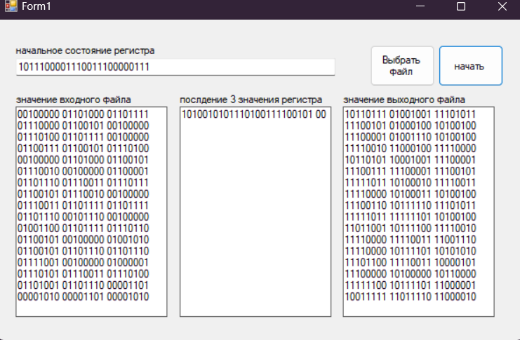

После расшифровки получился исходный текст

Тест 2: проверка на изображении

Входное изображение: Выходное изображение после расшифровки:



Видно что в после расшифровки изображение осталось прежним, следовательно на больших обьемах данных программа работает корректно.

Проверка на русских буквах

Входной текст:

Я вас любил: любовь еще, быть может,

В душе моей угасла не совсем;

Но пусть она вас больше не тревожит;

Я не хочу печалить вас ничем.

Я вас любил безмолвно, безнадежно,

То робостью, то ревностью томим;

Я вас любил так искренно, так нежно,

Как дай вам Бог любимой быть другим.

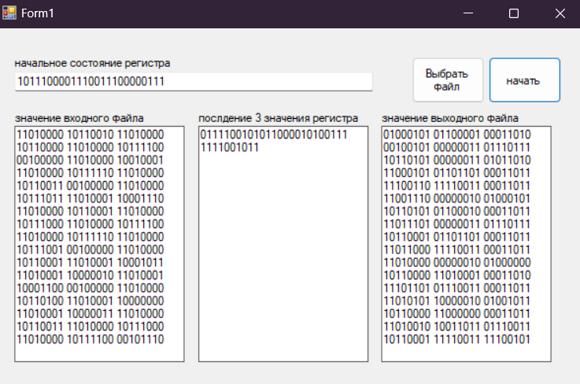

Выходной текст:

hЬЈhБSўЈ8yэSЈ;|И№ЊЈ8}эS#=|AR уS

|nЇЊ2}TR.Њ?|`v}\пЎФ>юD}Vюx|k5юu\n}^nж_c:юx_ls_jэ‚ШxЇy^QD^^Ж_l62^Ї\_b? т>>PЯi?ГfџgОЏo>кт?Щn‰g>кP€д>аѓlc_д€нО€ч>нn?ЭњP‰Л?Ыl>зњ‰Л~ињ€фЪќ&xњ€ьzЩl{eњIЛ{-њ¶AЎHг‹Lю{,ќ*јњMB{-\L‹L

{)lL {"nL

{!o•°џы-oѕLЫ!oіL

У)oµLТ"“–o "-?ТBoі$УunЂ'3Уy“"&ЅТI­Уwп·'ќТJчј&ўУuрЋ&Ї"&ЈRIс>'™RKЏэс-Чс4'‘UvTLр

'ђTс?·рG‘T-T/рE›Uс1ET(1:№бU4Ek¤ElT 2EnT+я‰џ^Ec/у!|EjиEa%wµZЕmжуОEµbЭw±mШуР@°СнsХ‚K°АТ›s±уе

Выходной текст:

Я вас любил: любовь еще, быть может,

В душе моей угасла не совсем;

Но пусть она вас больше не тревожит;

Я не хочу печалить вас ничем.

Я вас любил безмолвно, безнадежно,

То робостью, то ревностью томим;

Я вас любил так искренно, так нежно,

Как дай вам Бог любимой быть другим.

Попытка сохранить не охранить файл: 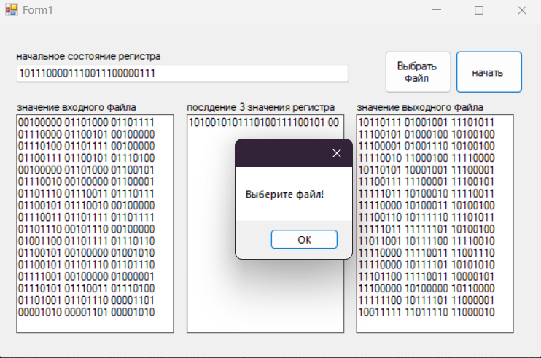

Попытка ввести слишком короткий ключ: 